NEW MEXICO OFFICE OF THE STATE HISTORIAN PRESENTS

TERTULIA HISTÓRICA LUNCHTIME LECTURE SERIES

NEW MEXICO’S JOURNEY TO STATEHOOD

DR. RICK HENDRICKS

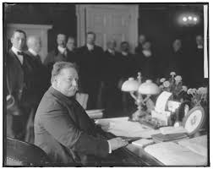

WEDNESDAY JANUARY 15, 2025 - 12noon

NEW MEXICO STATE RECORDS CENTER AND ARCHIVES or CLICK HERE [TEAMS](https://teams.microsoft.com/l/meetup-join/19%3ameeting_MDZhNjZhMTYtYjU1OS00OGJmLWE4MTEtMmM5NDhlMThlYzEz%40thread.v2/0?context=%7b%22Tid%22%3a%2204aa6bf4-d436-426f-bfa4-04b7a70e60ff%22%2c%22Oid%22%3a%224500571f-10b0-4aa1-b492-90e60ad378d4%22%7d)